1. *Window* (*this* is *Window*)

Drinks {} (*this* is Drinks())

1. 10

0

1. Oops Error: guessMe2 is not defined (Reason, guessMe2 is not defined, let not support variable hoisting)

1 3

1 2

1. Uncaught ReferenceError: arguments is not defined (We can’t access arguments of Arrow function)
2. 2
3. *undefined* *Window* (Here *this* denotes *Window*, so *this.i* is undefined)

10 {i: 10, b: ƒ, c: ƒ} (Here *this* denotes obj)

1. Uncaught TypeError: Foo is not a constructor (We can’t use Arrow function as constructor function)
2. Uncaught TypeError: Cannot set property 'name' of undefined
3. **Code snippet:**

const name = "Mike";

const age = "20";

const profile = () => { return { name, age } }

console.log(profile(name, age));

**Output:** {name: "Mike", age: "20"}

1. **Code snippet:**

const numbers = [65, 44, 12, 4];

const sum = numbers.reduce((total, num) => { return total + num; });

console.log('Total: ', sum);

**Output:** Total: 125

1. 120 (total*null = 0), 100+0+20=120
2. String
3. **Code snippet:**

function test2(num = 1000){

setTimeout(function(){ console.log('Haiiii'); }, num);

}

test2(5000);

**Output:** Haiiii

1. **Code snippet:**

function printComment(comment, line = 1){

console.log(line, comment);

}

let i = 0;

setInterval(function(){ printComment("Increment", i++); }, 1000);

**Output:**

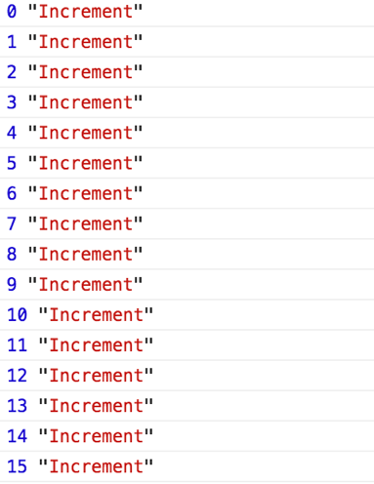

………

1. 12
2. **Code snippet:**

const greetings = to => msg => from => `Dear ${to},

${msg}

From,

${from}`;

const message = greetings('Mike')('Wish you Happy Birthday!')('Steve');console.log(message);

**Output:**

